2303A51620
Lab assignment-12.3

Task 1: Sorting Student Records for Placement Drive
Scenario
SR University’s Training and Placement Cell needs to shortlist candidates
efficiently during campus placements. Student records must be sorted by
CGPA in descending order.
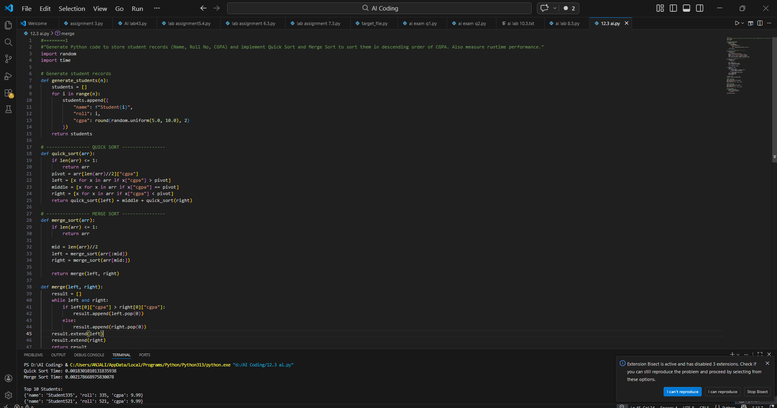
EXPLAINATION: This task focuses on sorting student records based on CGPA in descending order to shortlist candidates efficiently. Quick Sort and Merge Sort are implemented using AI assistance and compared based on execution time. Performance analysis helps determine which algorithm works better for large datasets. The top 10 students are displayed after sorting.

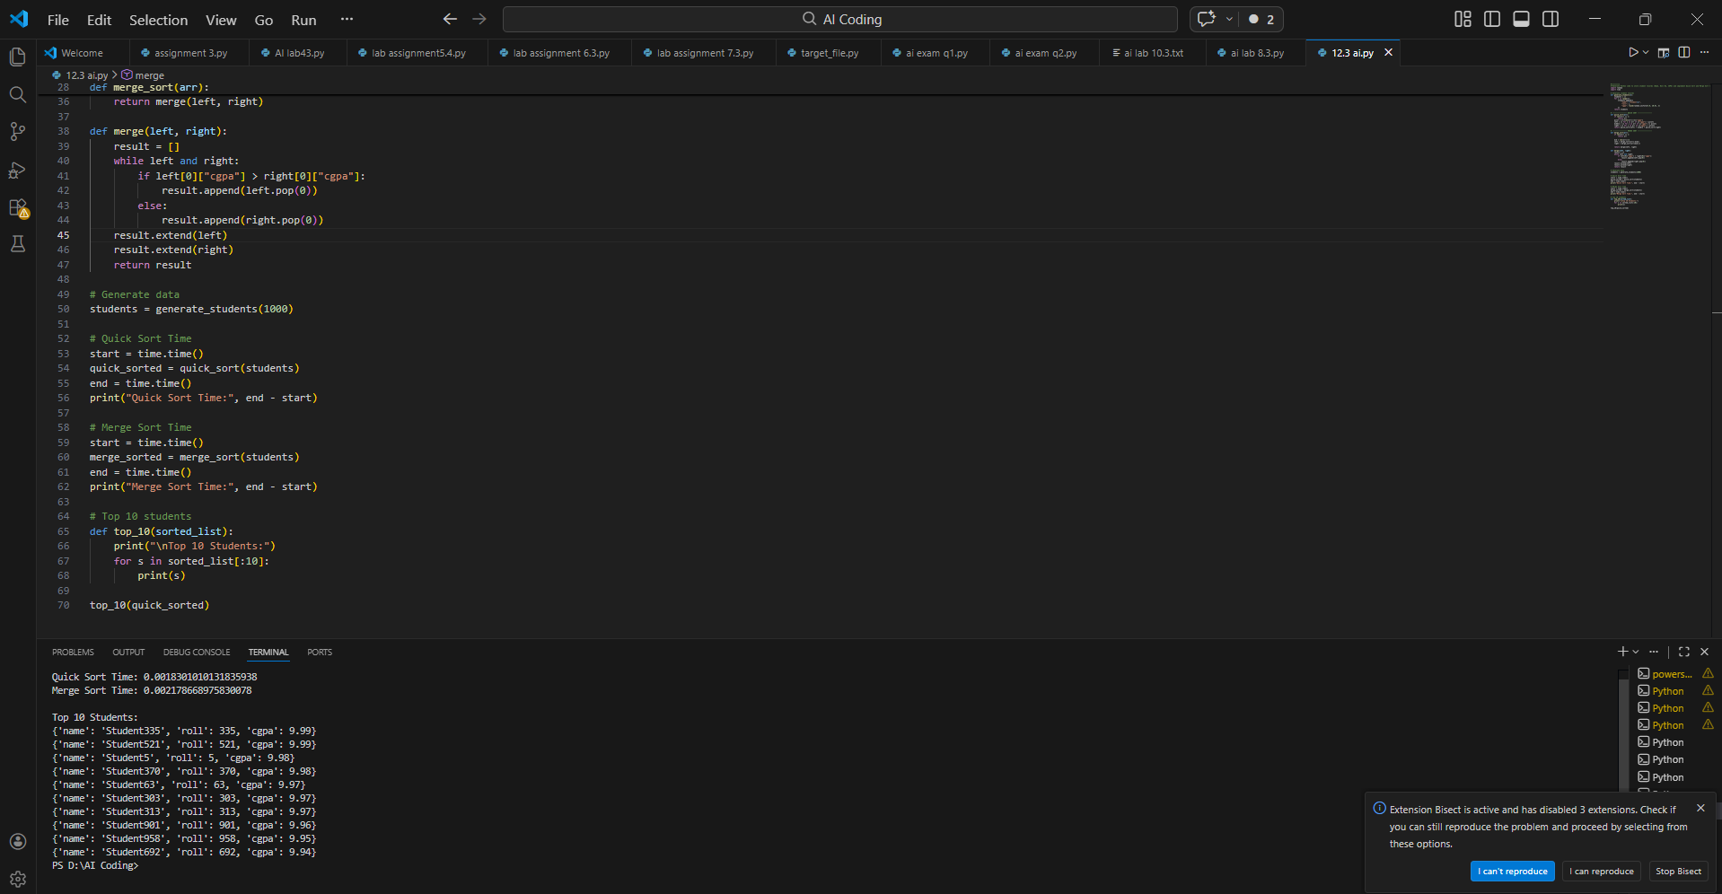
Task 2: Implementing Bubble Sort with AI Comments
• Task: Write a Python implementation of Bubble Sort
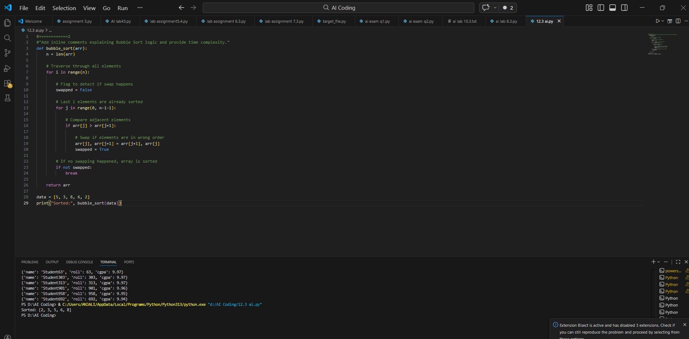
EXPLAINATION: In this task, Bubble Sort is implemented in Python with detailed AI-generated comments explaining each step. The algorithm repeatedly swaps adjacent elements until the list is sorted. Time and space complexity analysis is included to understand its efficiency. This task helps evaluate why Bubble Sort is not suitable for large datasets.

Task 3: Quick Sort and Merge Sort Comparison
• Task: Implement Quick Sort and Merge Sort using recursion
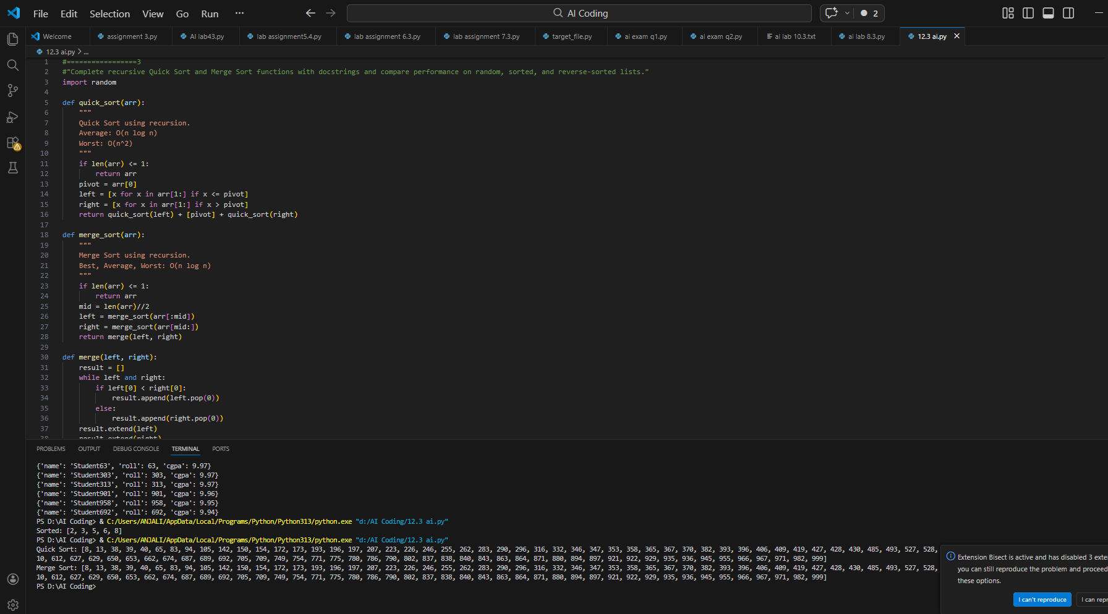
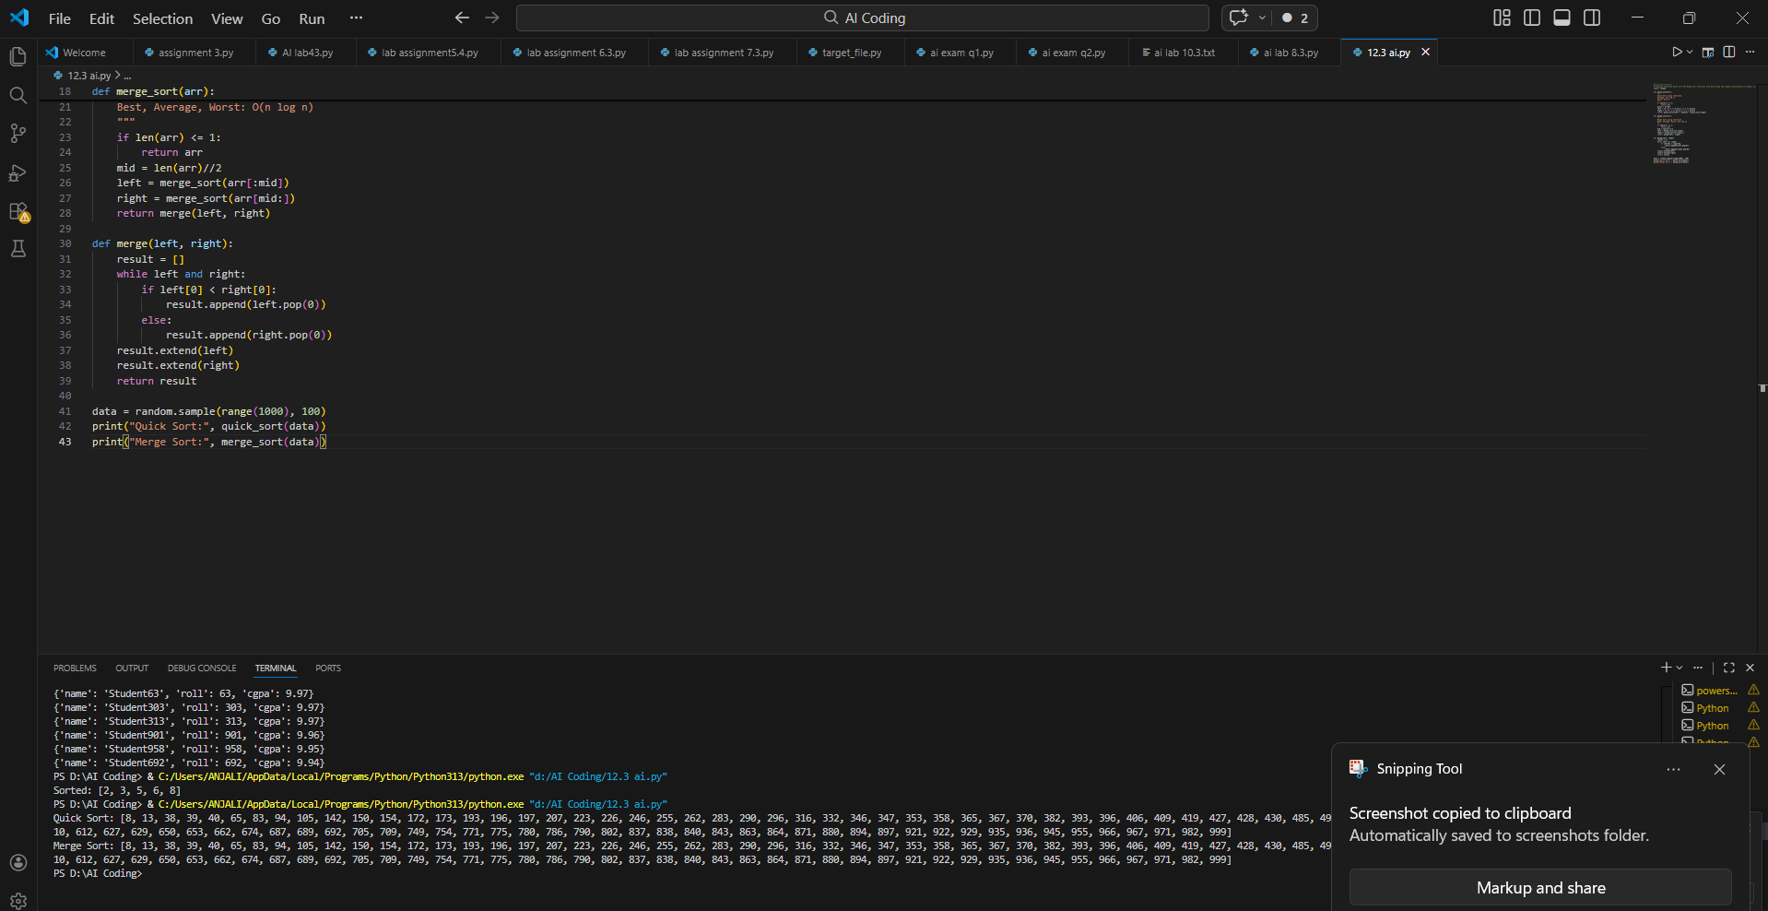
EXPLAINATION: In this task, Bubble Sort is implemented in Python with detailed AI-generated comments explaining each step. In this task, Bubble Sort is implemented in Python with detailed AI-generated comments explaining each step. The algorithm repeatedly swaps adjacent elements until the list is sorted. Time and space complexity analysis is included to understand its efficiency. This task helps evaluate why Bubble Sort is not suitable for large datasets.
Time and space complexity analysis is included to understand its efficiency. This task helps evaluate why Bubble Sort is not suitable for large datasets.

Task 4 (Real-Time Application – Inventory Management System)
Scenario: A retail store’s inventory system contains thousands of products,
each with attributes like product ID, name, price, and stock quantity. Store staff
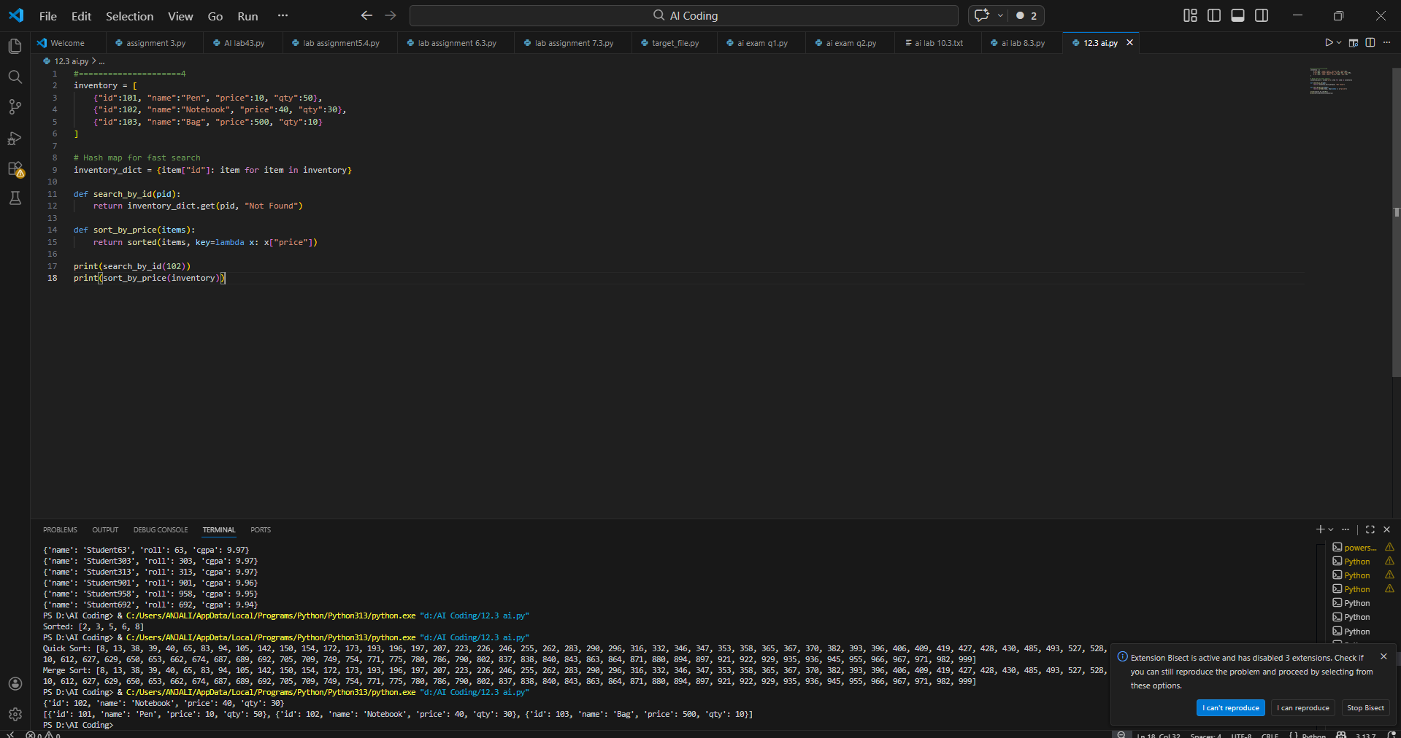
EXPLAINATION:
This task applies searching and sorting algorithms in a real-world inventory system. A Hash Map (dictionary) is used for fast product searching, while efficient sorting algorithms are used for price and quantity sorting. The choice of algorithms is justified based on large dataset size and frequent searches. Performance and complexity analysis are included.

Task 5: Real-Time Stock Data Sorting & Searching
Scenario:
An AI-powered FinTech Lab at SR University is building a tool for analyzing
stock price movements. The requirement is to quickly sort stocks by daily
gain/loss and search for specific stock symbols efficiently.
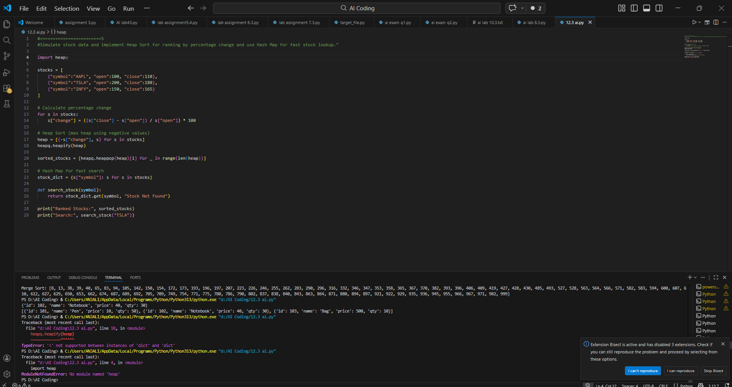
EXPLAINATION: This task simulates stock data and calculates percentage gain/loss for ranking. Heap Sort is implemented to efficiently sort stocks by performance. A Hash Map is used for instant stock symbol lookup. The performance is compared with Python’s built-in functions to analyze trade-offs.

